CONGRUENT TRIANGLES
Pearson Edexcel - Tuesday 19 May 2020 - Paper 1 (Non-Calculator) Foundation Tier

Pearson Edexcel - Monday 12 November 2018 - Paper 3 (Calculator) Foundation Tier

OCR Tuesday 12 June 2018– Morning (Calculator) Foundation Tier
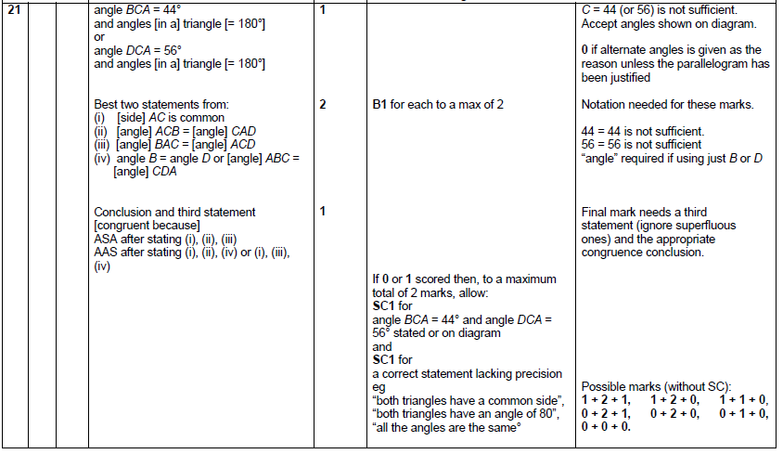

AQA Sample Paper 2– Morning (Calculator) Foundation Tier

